
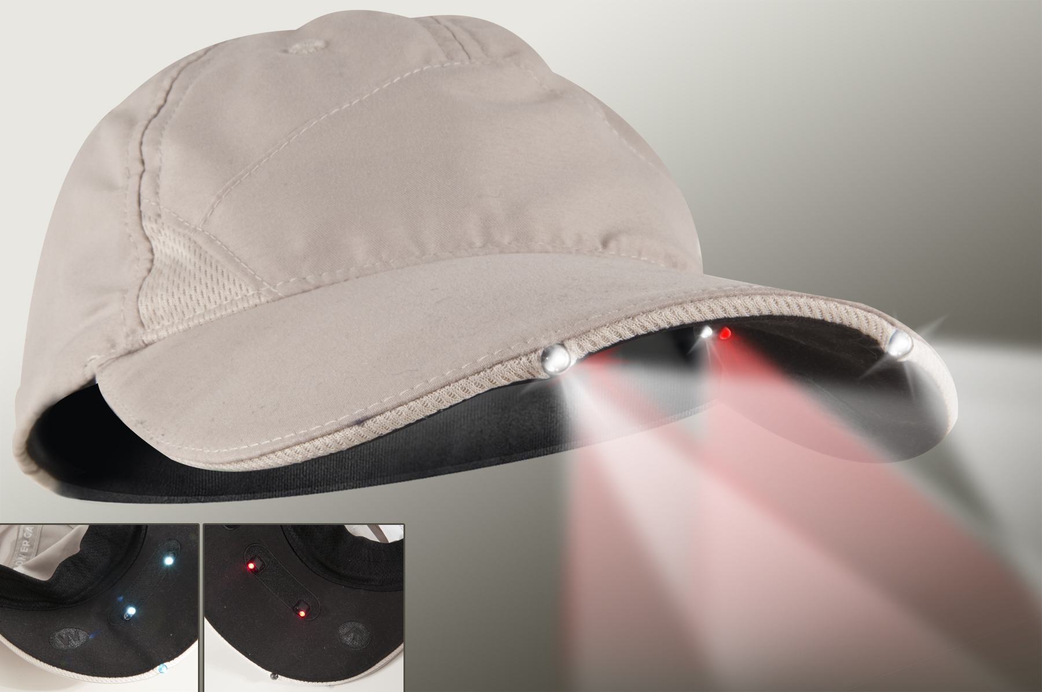
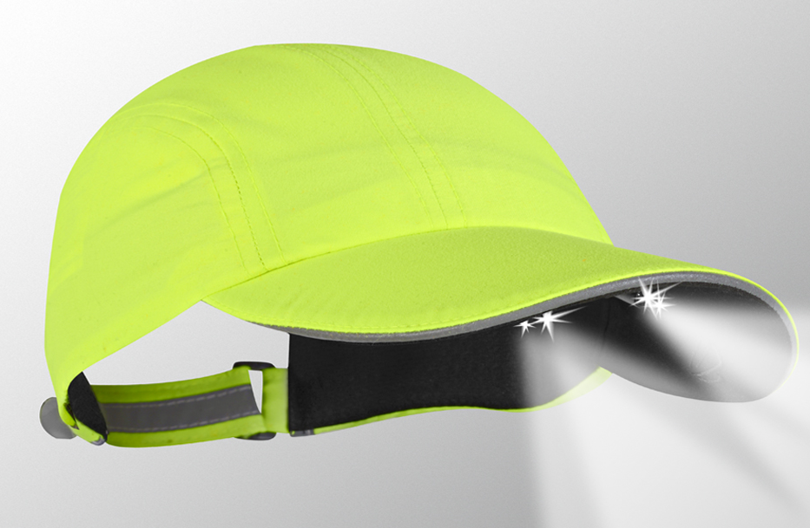
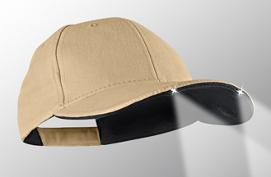
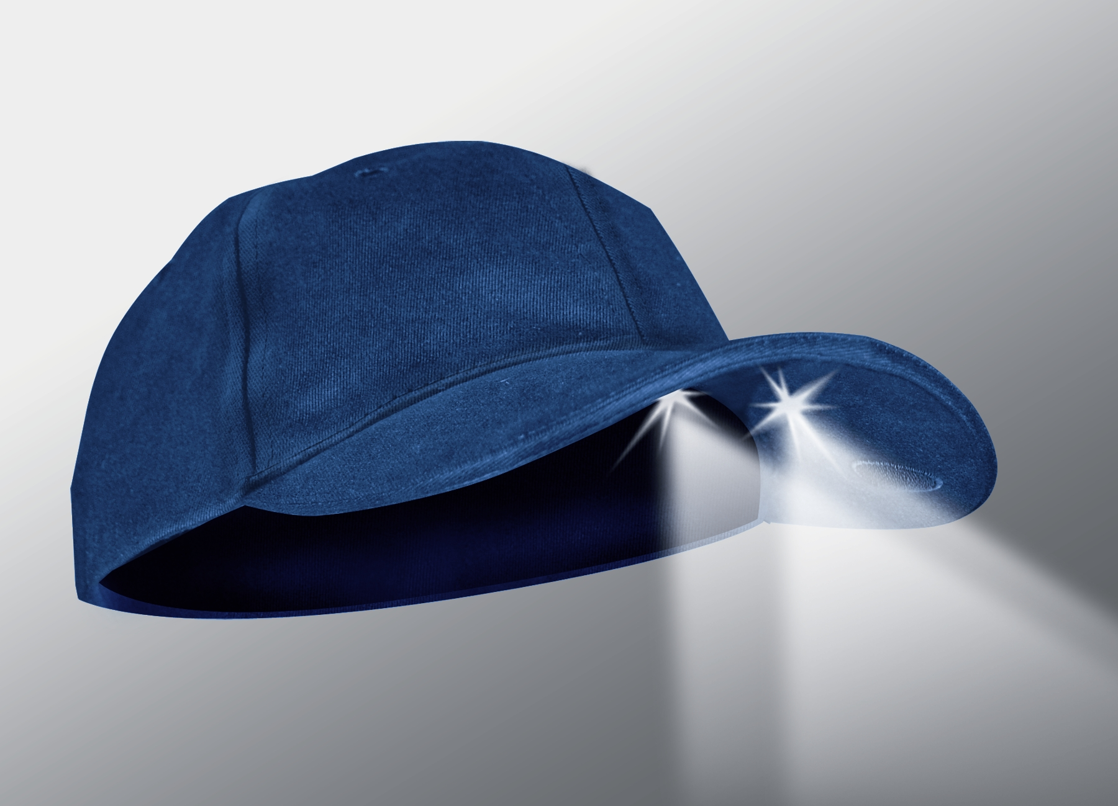
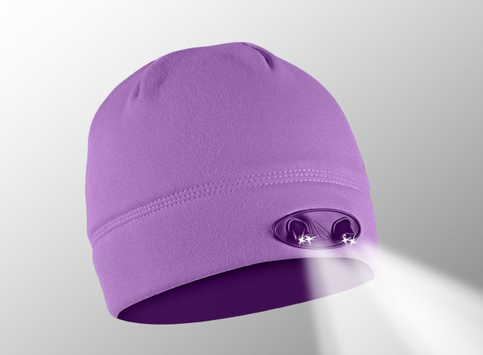
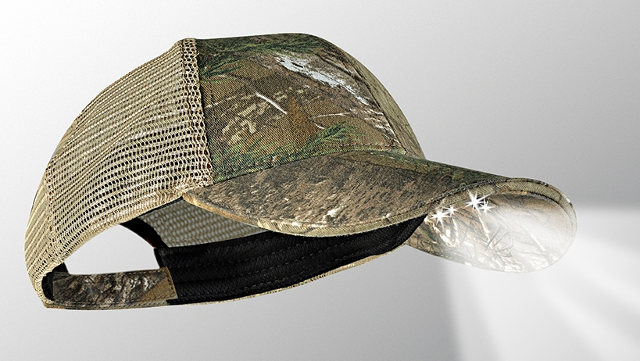


Type your information here

VISIT OUR WEBSITE WWW.PANTHERVISIONPROMO.COM
TO SEE THE FULL LINE OF LIGHTED PRODUCTS
OR CALL 847.783.5900 x 116 FOR MORE INFORMATION

CAMPING ...THE BEST CURE FOR SPRING FEVER

Stealth Navigator in Tan
PS6-146
Stealth 2575 Runner in Yellow
PR4-177
Get out and enjoy the weather with a
CAPLIGHT or POWERCAP

The “ultimate hands-free flashlight”, with high and low beam directional lights for distance and up-close tasks.

Easy on/off switch concealed under brim.

50+ hours continue battery life.

Because of the many uses,
POWERCAP delivers low cost per impressions

VISIT OUR WEBSITE WWW.PANTHERVISIONPROMO.COM
TO SEE THE FULL LINE OF LIGHTED PRODUCTS
OR CALL 847.783.5900 x 116 FOR MORE INFORMATION

ASI 75825 SAGE 68668 PPA 318255

VISIT OUR WEBSITE WWW.PANTHERVISIONPROMO.COM
TO SEE THE FULL LINE OF LIGHTED PRODUCTS
OR CALL 847.783.5900 x 116 FOR MORE INFORMATION

Caplight in Tan
CL2-174
Stealth 2500 in Navy
PS2-118
Stealth 2575 PS4-171
REALTREE Xtra with mesh back
Stealth 3555 in Orchid
WB-5628
Stealth Navigator in Tan
Stealth 2575 Runner in Yellow
More colors available in each style below

