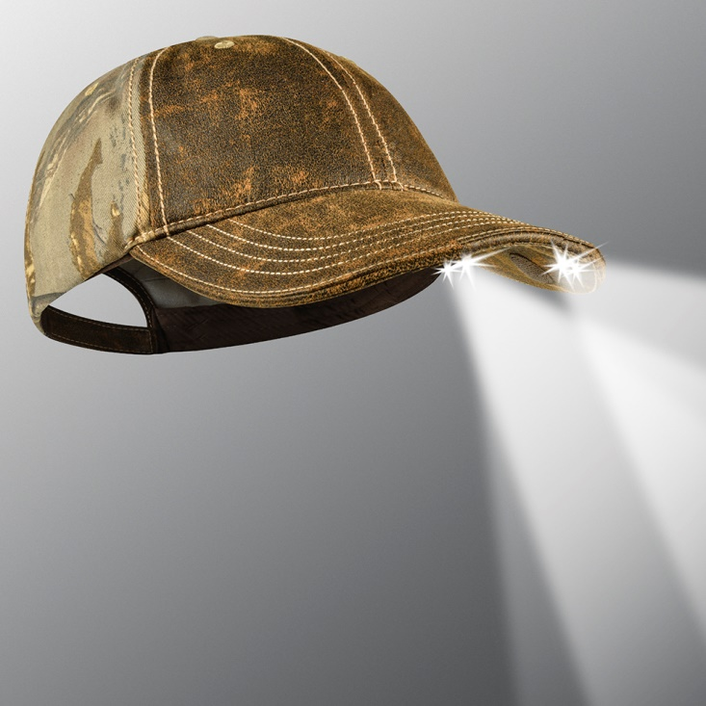
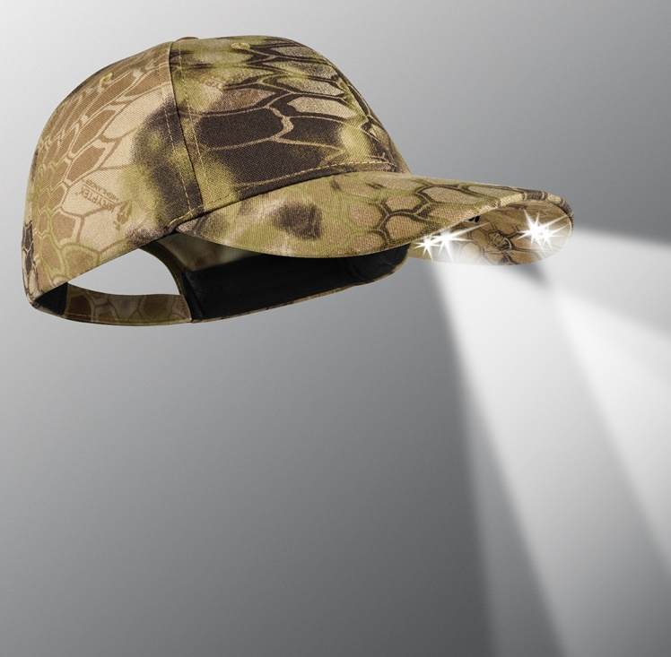
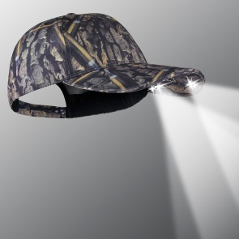
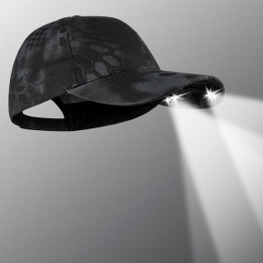
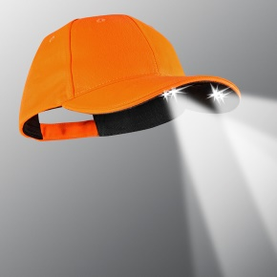
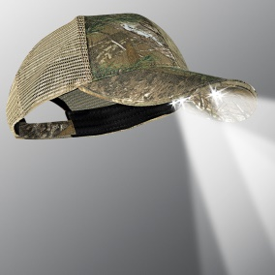
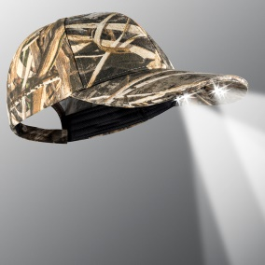
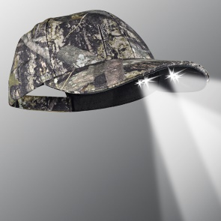
Add your information
and logo here.
MODEL PS4-7097

VISIT OUR WEBSITE WWW.PANTHERVISIONPROMO.COM
TO SEE THE FULL LINE OF LIGHTED PRODUCTS
OR CALL 847.783.5900 x 116 FOR MORE INFORMATION

VISIT OUR WEBSITE WWW.PANTHERVISIONPROMO.COM
TO SEE THE FULL LINE OF LIGHTED PRODUCTS
OR CALL 847.783.5900 x 116 FOR MORE INFORMATION

VISIT OUR WEBSITE WWW.PANTHERVISIONPROMO.COM
TO SEE THE FULL LINE OF LIGHTED PRODUCTS
OR CALL 847.783.5900 x 116 FOR MORE INFORMATION

ASI 75825 SAGE 68668 PPAI 318255

VISIT OUR WEBSITE WWW.PANTHERVISIONPROMO.COM
TO SEE THE FULL LINE OF LIGHTED PRODUCTS
OR CALL 847.783.5900 x 116 FOR MORE INFORMATION

VISIT OUR WEBSITE WWW.PANTHERVISIONPROMO.COM
TO SEE THE FULL LINE OF LIGHTED PRODUCTS
OR CALL 847.783.5900 x 116 FOR MORE INFORMATION

Introducing two new camos to our amazing lineup
POWERCAP® 2575 Lighted Headwear

MODEL PS4-203

The “ultimate hands-free flashlight”, with
high and low beam directional lights for
distance and up-close tasks.

Some of the great features
48 Lumens of light output
22 meters of forward lighting
Four replaceable lithium CR-2032 batteries
Adjustable hook and loop closure

Convenient 3-way multifunctional lighting
control switch concealed under brim

Easily add your logo with
embroidery or heat transfer

REALTREE Xtra with brown weathered front and brim. PS4-7097 stylish all-purpose camo with heavy stitching, relaxed
unstructured style. The solid front panels allow logo to POP!

Kryptex Highlander™ model PS4-203 was specially designed
for those geographical regions and elevations that are varied. Kryptek Highlander™ increases stealth when pursuing a wide range of prey in mixed terrain, particularly in our western region.
PS4-199

PS4-178

PS4-167

PS4-202

PS4-7097

PS4-137

Additional camo options in the PowerCap® Stealth 2575

